House Sarah Resource

…..transforming the lives of those who come seeking help… 6 Desvouex Road Suva 6793100665

Of

[www.houseofsarah.org](http://www.houseofsarah.org)

**3. What is real story?** 

**Statistics**

**All the statistics and text in this paper below are from the Fiji Women’s Crisis Centre’s -‘Somebody’s Life Everybody’s Business- National Research on Women’s Health and Life Experiences in Fiji (2010-2011) – A survey exploring the prevalence, incidence and attitudes to intimate partner violence in Fiji**

**“The global prevalence for physical and/or sexual intimate partner violence over a woman’s lifetime is 30%, compared with 64% in Fiji”.**

**It is not all physical**

***“The complex web of control, intimidation, humiliation and multiple forms of violence needs to be recognised by all service providers who aim to prevent violence and assist women living with violence***. Coercive control by husbands and partners prevents women and girls from finding out about their legal and human rights and the services available to help them. It prevents them from reporting the violence to authorities and getting the help they need from health services and other agencies for their injuries trauma. It also prevents women from telling their family and friends about the violence.”

**How women cope with the violence?**

“Women show enormous resilience and strength in the face of repeated and serious violence and abuse. The findings demonstrate that they try to cope with the violence themselves before telling anyone about it.

* Only 53% of women living with violence have ever told anyone about it – usually their family
* 40% of women who experience violence have left home temporarily at least once due to violence but disclose the true reason for leaving
* Only 24% have ever gone to an agency or formal authority for help, and the police and health services are usually the first agencies that women go to.
* 3 in 5 women (58%) believe that people outside the family should not intervene if a man mistreats his wife. “

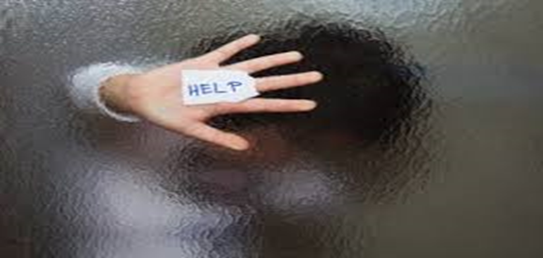

“When women do take the very difficult step of asking for help or leaving home, the evidence shows that the majority do so because the violence is extremely serious, they cannot endure any more, or because they are badly injured. “

***C:\Users\Ann Drummond\AppData\Local\Microsoft\Windows\Temporary Internet Files\Content.IE5\M0RTD3VC\MC900391320[1].wmf***

***“Service-providers, traditional and church leaders, families and friends need to take note of these findings by not condoning, excusing or tolerating the violence. When women do ask for help or leave home, it means that the problem has reached crisis point. Requests for help need to be taken seriously; service-providers, families and friends need to respond appropriately to ensure that women’s rights, health, access to resources and life are protected.”***

***Somebody’s Life, Everybody’s Business. FWCC***

Sarah Carers’, clergy and church leaders please note!

**Health, social and economic impacts of violence against women and girls.**

**“Intimate partner violence against women imposes a high burden of injury on women and it cost the economy:**

However, the findings also show that women under-estimate the impacts of violence on their health and well-being (an important coping strategy for many women); only about 1 in 10 tell a health worker the true cause of their injury, and many do not get the health care they need.

With 30% of ever-partnered women injured due to domestic violence in their lifetime, and a significantly increased risk of emotional distress symptoms including suicidal thoughts and actions, domestic violence is undoubtedly one of the biggest risks to women’s physical health and mental well-being in Fiji. “

***“43 women are injured, 1 is permanently disabled, and 71 lose consciousness every day in Fiji; 16 women are injured badly enough every day to need health care.”***

***Somebody’s Life, Everybody’s Business. FWCC***

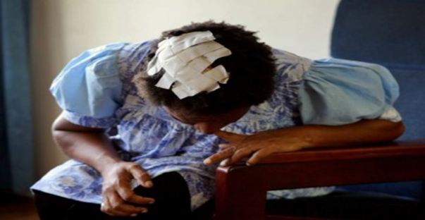

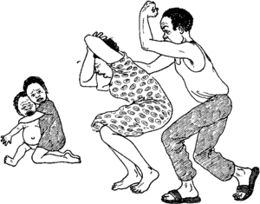

**Children**

“Domestic violence has negative impacts on children’s emotional well-being; it is associated with increased aggressive behaviour in some children, and increased timidity and social withdrawal in others. Children whose mothers are subjected to intimate partner violence are significantly more likely Children whose mothers are subjected to intimate partner violence are significantly more likely to fail or repeat at school. These impacts affect both boys and girls; they reduce their life opportunities and pre-dispose them to the risk of violence in their own intimate relationships in adult life, as either perpetrators or survivors. These findings have highlighted the fact that children need emotional support to address the range of emotional and behavioural problems that they experience due to violence perpetrated against their mothers. Most importantly, they need the violence to stop. A range of economic and social costs of domestic violence have been highlighted by the survey findings.”

**All of the above is quoted directly from the Fiji Women’s Crisis Centre’s -‘Somebody’s Life Everybody’s Business- National Research on Women’s Health and Life Experiences in Fiji (2010-2011) – A survey exploring the prevalence, incidence and attitudes to intimate partner violence in Fiji available through the Fiji Women’s Crisis Centre – 88 Gordon St Suva Fiji. Prepared by the House of Sarah (**[**www.houseofsarah.org**](http://www.houseofsarah.org) **)**