House Sarah Resources
…..transforming the lives of those who come seeking help… 6 Desvouex Road Suva 6793100655
Of
www.houseofsarah.org

Resources for Parishes
The aim of this pack is to enable churches to address family violence both within their own parish/congregation and the wider community. It is intended to raise awareness and to highlight some of the areas that need to be considered in making our churches a safe and welcoming place for survivors of family violence.
This is not an all-inclusive resource. The information contained within it will not equip individual clergy or church leaders to be able to respond fully to the needs of those who are suffering or who have suffered from aspects of family violence. But it will provide information for which is helpful.
The majority of family violence is perpetrated by men against women. However, family violence can be inflicted by women on men and also in same sex relationships so while the resource refers to women as the survivors of abuse and men as the perpetrators, Christians should treat the needs of male victims with equal concern.

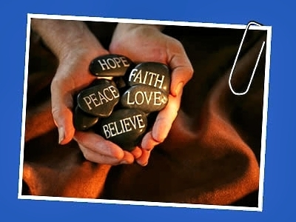

“I have come that they may have life and have it abundantly”
— John 10:10

Resource Package Contents

- Diocese of Polynesia’s Commitment
- What is Family Violence?
- What is the Real Story?
- Misconceptions about Family Violence
- Family Violence and the Laws of Fiji
- What Help is available for Survivors of Family Violence?
- Do’s and Don’ts - supporting a Survivor
- Do’s and Don’ts - when dealing with a Perpetrator of Family Violence
- What can your church do about Family Violence?
- Using the Bible to challenge Family Violence

In Fiji:
“43 women are injured,
1 is permanently disabled,
and 71 lose consciousness
every day.
16 women are injured badly
enough every day to need
health care Fiji Women’s Crisis
Centre’s National Research on Women’s
Health and Life Experiences in Fiji-2010-2011
Commitment of the Diocese of Polynesia
“…. That within the
Diocese of Polynesia there
be Zero Tolerance of
Violence within our homes,
our schools our
communities and
the church”---Motion Passed at the 2013 Diocese of Polynesia Synod

House of Sarah –established in 2009 To:
- provide Christian care, support and referral for survivors of family violence
- raise awareness of the issue of violence within the church and community
- provide resources for church communities
- network ecumenically with other denominations working with survivors of family violence

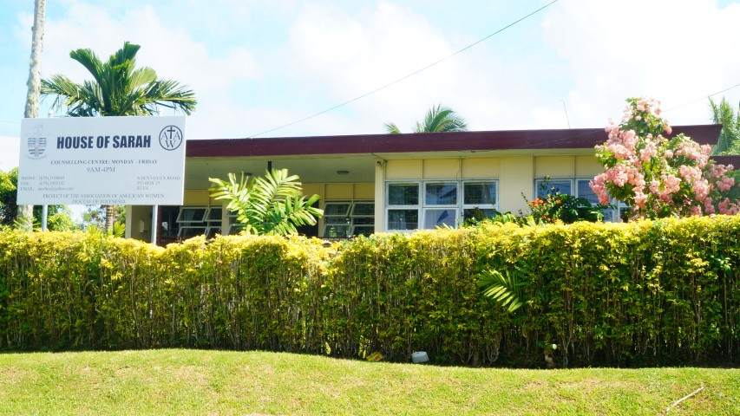

This Resources Kit has been adapted with permission from the Restored Church Kit (www.restoredrelationships.org) to be appropriate to the Fijian context. It has been produced by the House of Sarah – 6 Des Vouex Road, Suva.
Phone 3100665
Email: aawhos@yahoo.com www.houseofsarah.org

Simeon Ministry – established in 2011? To:
- Raise awareness of the issues of family violence within the Men’s fellowships in churches.
- Refer perpetrators to appropriate counselling

Synod of Polynesia Zero Tolerance Strategic Plan
- Re-examine the teachings of the Bible as the foundation of loving, safe, equal and respectful relationships in family, church and community life.
- Maintain our focus on a building safe, respectful family life where girls, women, boys and men can live and grow together without fear.
- Advancing Primary Prevention Initiatives.
- Advancing the work of the Diocese with men and perpetrators of violence.
- Promoting Church policy and legislation to address primary prevention services.
- Ensure a monitoring and evaluation system is developed to track progress in the implementation of the programme components of the Zero Tolerance Policy.

